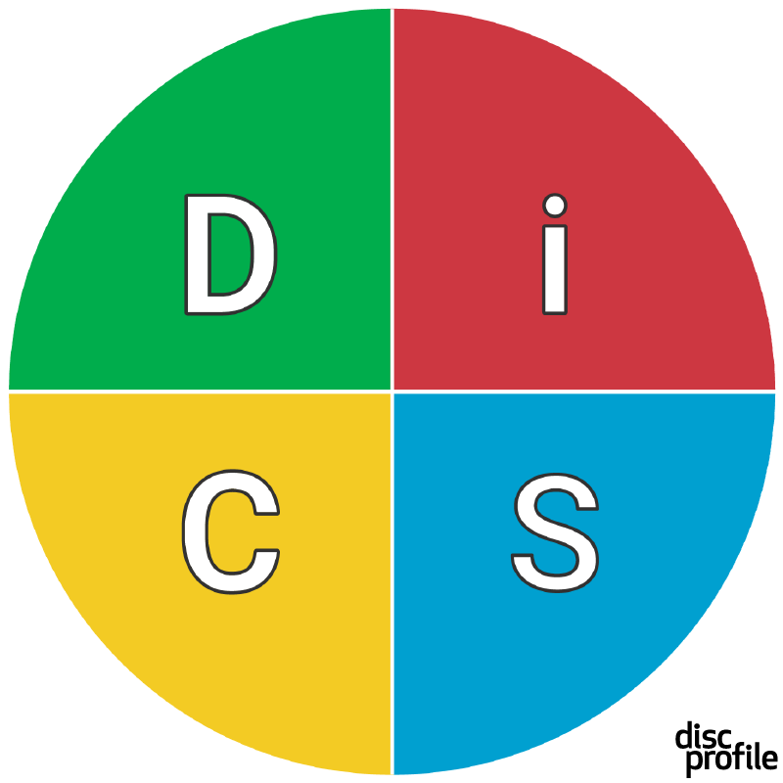

Name:

DiSC style:

Priorities:

Things I do that are reflective of my style:

Things I do that aren’t reflective of my style:



Name:

DiSC style:

Priorities:

Things I do that are reflective of my style:

Things I do that aren’t reflective of my style: